
Evaluating Wikipedia Content
Wikipedia has three core "content policies":
- Neutral Point of View: Wikipedia content must represent fair, proportional, and unbiased, views on the topic.
- Verifiability: anyone using the encyclopedia can check that the information comes from a reliable source.
- No Original Research: Wikipedia is not a place for original research, or original thought.

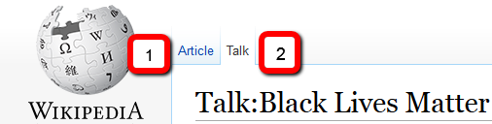
1). Article page; 2). Talk page

Task: Look up your own research topic, or a topic that you’ve discussed in class. In addition to the article (1); refer to the ‘TALK’ page (2) to see the conversation/evolution around the article’s content. The TALK page will cite specific discussions around violations of the 3 Wikipedia content policies.

Neutral Point of View

Verifiability

No Original Research

