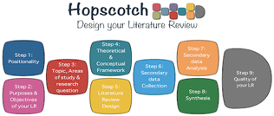
<<Problem>>
<<Question>>

<<Population>>
<<Setting>>

<<Theory>>

<<relations>>
<<Concept >>
<<Concept>>
<< Research Design>>
<<relations>>
<<Concept>>
<<research study>>
<<research study>>
<<Results>>
Themes
Gaps
<<Results>>
Purposes of the review
Gap
<<research study>>
<<Results>>
Gap

