Research Wizards
Players: 3-5
Play Time: 20-30 minutes

The most powerful wizards have gathered to battle one another. Only one will win. Wizards must use reliable sources to research incantations for the battle, or their spells will fizzle. Truly wise wizards must learn to tell the difference. Feel free to use the wizard voice of your choosing while playing the game.
Learning Outcomes:
- Wizards will define a variety of traditional and emerging information formats.
- Wizards will compare a variety of information formats and discuss their relative reliability.
- Wizards will explore the variation in quality found within specific categories of information (e.g., the wildcard of using resources located by or generated with artificial intelligence).
Preparation. Separate out:
- The 45 cards in the main deck. Each card has a suit (information category), identified by its icon and color. Cards also have a point value at the top and bottom of the card and a description of the resource.
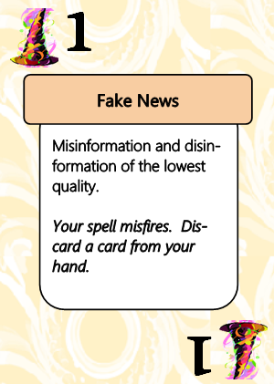
Research Wizard s
Card back Card front
b) The 5 miniature-sized cards, which will be ranked during parley. Each design represents a different suit. Wild Cards are the highest rank, and can only be beaten during battle by another Wild Card worth more points.





Library Resources
Internet Resources
Social Media
Wild Card
Artificial Intelligence


c) The 5 spell of vengeance cards, which should be set aside in a face-down pile for the final rounds.

Phase 1: Parley. Examine the five miniature cards and decide together how to rank the suits, based on how reliable or trustworthy such a resource from that category would typically be. Arrange the cards in the rank order that your group agrees upon, from least valuable to most. Wild Cards will always be considered the top ranking category; they beat other all other cards during gameplay. Keep the Resource Ranking chart at the side of the table for reference during gameplay after parley is concluded.
Phase 2: Battle. Deal ten cards to each player (nine if playing with five), and start a discard pile with the cards left over. Players arrange their cards in a pile face-down in front of them. For each round of battle, players should flip their top card at the same time, and read the text written on their card. Players should immediately carry out any special actions indicated in bold font at the bottom of their cards. The card with the highest suit wins; wild cards always win, unless matched by another wild card with a higher point value. If two cards are flipped in the same suit, the card with the highest point value written at the top of the card wins. The winning wizard collects all cards from the battle, and play is repeated. When a player runs out of cards, they should shuffle their winning cards and continue.

Challenge. Be sure to read the text of your card during battle! If you believe your card should win but it isn’t the highest ranked (because there is a card of higher rank on the table), call a challenge. Make your argument to the other wizards at the table, and they must decide the winner. If you lose a challenge, you must give an additional card from your deck to the winning wizard. Challenged wizards simply lose the round. If a tie is declared, wizards should each flip a second card from their hand, and the winning card will take all cards in play.
Phase 3: Vengeance. Players lose when they run entirely out of cards and can no longer battle. But wizards go out in a blaze of glory, casting a final spell of vengeance on the remaining players. When players run out of cards, they should immediately draw a card at random from the face-down vengeance deck and read it aloud in their most doomful wizard voice. All players still in the battle must immediately follow the text directions. All cards discarded as the result of a spell of vengeance are taken permanently out of play.
Phase 4: Victory. The last player with cards remaining wins the battle. If time runs out before there is a winner, the wizard with the most cards in their hand wins.
Discussion questions:
  - What did you learn about sources?
  - What was more important for determining source quality, the source type or the number score (quality of the individual source)?

