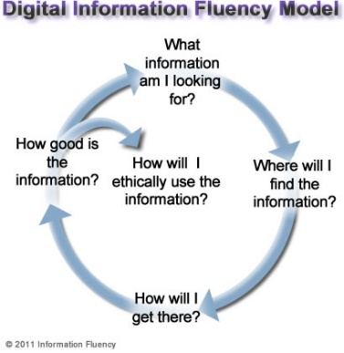
Information: Needs, Types, Qualities

Learning Outcomes
Students will be able to articulate the type of information they need to complete a given task.
Students will be able to identify the appropriate uses for various information formats.
Students will be able to explain the criteria by which we identify the credibility of an information source.
Students will be able to identify which attributes of a given information source should be included in an annotated bibliography.

Module Type
Group discussion; whiteboard

Time
10-15 minutes

Outline
This activity proceeds via Socratic questioning. The goal is to have students explain the common stumbling blocks they encounter as they look for information and as they write papers (if they have). The role of the librarian is to facilitate the discussion by providing a contextual framework for student experiences. By showing students that their research process follows a common pattern, they can make better choices about how, when, and where to look for information (e.g., not jumping straight to peer-reviewed articles when they can barely define their topic)
- Ask students for a handful of volunteer questions. Write on the whiteboard.
- ASK: “Let’s say I was researching X and I didn’t know anything about it. Where would you have me go to learn a little bit more?”
  - DESIRED ANSWERS: Wikipedia, google, a book, dictionary, etc.
  - Introduce students to concept of Background Information as an information need. This includes definitions, important events, important people, related issues, etc. Write this need on the board.
- ASK: “Okay, now I know more about what I’m interested in, but why should my readers care?”
  - DESIRED ANSWER: Because topic X is relevant to something going on right now
  - Remind students that a persuasive essay has to persuade and that they need a “hook” to make their ideas resonate with their readers (ethos). They need Current Events. Write this need on the board.
- ASK: “But isn’t this a small issue? Does it really affect everyone? How can we prove that this issue affects lots of people?”
  - DESIRED ANSWER: Show how many people are affected.
  - Students have a need for Data/Statistics. Write this on the board.
- ASK: “Okay, but people argue about this. Can’t I just grab the first opinions I sort of agree with and call it a day?”
  - DESIRED ANSWER: No. You need reliable and credible opinions.
  - Students have a need for Analysis. Write on the board
- ASK: “Sweet. I’ve got the basics, the contemporary angle, some stats, and some really good opinions. But what do I make of this article that says ‘A recent study has shown…’?”
  - DESIRED ANSWER: Find the study!
  - The final need is for the actual Research. Write on the board.
  - Reading through the research will often lead to new needs for background information and the cycle will start over.
- Note that not all information can help with all five of these needs.
- Go through each of the five needs and ask what Information Types best meet each need. List these on the board.
- Note that sometimes a piece of information is crap. Introduce the CRAP test as a measure of Information Quality.
- See the final table below. The whiteboard should look something like this:

Information Needs  Background  Current events  Data/Statistics  Analysis/Opinion  Research | Information types  Dictionaries/Encyclopedias  Wikipedia  Websites  Books  Newspapers/websites  Radio  Television  Social media  Government websites  Non-profits  Blogs  Magazines  Essay websites (e.g., Salon)  Scholarly books  Scholarly articles | Information Quality  C – Currency  R – Reliability  A – Authority  P – Purpose

- Show students that they now have the concepts they need to start annotating their articles. If they went through a method to find their articles they can now say:
  - What type of information their source is (book, article, etc.)
  - What need the source fills in their paper/argument.
  - How reliable, current, authoritative the article is in the context of their assignment
  - How they intend to use the source.

Reflection
This activity gets a great response from instructors.

