DEVELOPING YOUR RESEARCH TOPIC
This exercise is designed to help you develop a thoughtful topic for your research assignment. Answer the following questions to help you better understand and refine your thinking about your research topic.
A
C
B
HOW
How does one aspect of your topic affect another? How serious is the issue/problem?
WHAT
What is the issue or problem? Consider the “so what” of your topic. Why should it matter to others?

WHERE
Where did it begin? Is there a geographic location you want to focus on? Where does it fall on the moral spectrum (Good/Bad/Just)?

WHO
Who is involved? Whom does it affect? Is there a specific population you want to focus on? Identify the stakeholders and their opinions.

Think about the following elements of your topic:
Choose a community issue or problem that matters to you. What social injustice do you see? Don’t have a topic? Browse the following online library resources for inspiration: CQ Researcher, Opposing Viewpoints, or TED talks. You can find links to these sites at http://libguides.lmu.edu/needatopic
Why did you choose this topic? In 2 or 3 sentences, explain why you are interested this topic (Examples: This directly impacts me or someone I know by…, or Hearing about this topic stimulated me to learn more because…)

What research topic interests you?
How did you become interested in this topic?
Consider the varying ways that stakeholders define key terms. Do different people define or “see” things differently? Example: X defines “racial profiling” as _________, but Y explains it as _________, which includes implicit (or unconscious) bias.

A good way to enter the conversation of a field or discipline is to study the vocabulary and theories. List the concepts or theories here:

Subject tags are often great search terms! What are some useful search terms for your topic?
Hint: Think about key concepts or synonyms

Be flexible and creative in their use of language Search terms are contingent on who is speaking. Rhetorical nature of subject headings is pointed out.

D
Could you identify any scholars or experts who do research on your topic?
Did the articles cite any useful sources that would be useful for your research?
Did you find any additional keywords to use when you search?
Did you identify any major concepts or theories related to your topic?
Define the basic terms used in this issue
List additional sources here:
Keywords change based on who is speaking, for example, a scholar might say “preadolescent,” whereas a journalist might say “tween.” List new keywords here:
They may be identified or listed as Further Resources. List the experts/scholars here:
Search Google, Wikipedia, and the online library resources CQ Researcher, Opposing Viewpoints, Gale Virtual Reference Library, or Sage Knowledge to find basic background information about your topic and answer the questions below. Links to the online library resources mentioned above can be found here: http://libguides.lmu.edu/FindSources

Do background reading:
EFE
Social Structures & Social Justice

Social Structures - What roles do social structures play in your issue or problem? “At issue is not the goodness of the individual person living in the system, rather it is the system itself called into question.” Looking at your issue or problem, can you answer (at least 2 of the 5) following questions?
- Economics - What is the role of economics in this issue? Who benefits? Who is burdened? Who is responsible?
- Politics - What is the role of politics in this issue? Who has power? What kind of power? What role does politics play in the history of this issue?
- Culture- What is the role of culture in this issue? Which cultures play a prominent role?
- Environment - How is the environment impacted? How is the issue impacted by the environment? What is the geography of the issue? (Where is this happening or potentially happening?)
- Religion- What roles does religion play in the history of this issue?

The Common Good and Social Justice - Different social groups have different levels of access to social power and resources based on a variety of historical, political, economic, and social factors as you have examined above. These inequalities inhibit our ability to promote the common good. Social justice refers to efforts to combat these large-scale inequalities and achieve economic, legal, political, and social equality for all.
Based on what you know, so far, about your social issue, name one social group you think is among the most negatively affected by the status quo (the way things are). Explain your reasoning.
(Hint: Social group refers to a group of people who share some physical, cultural, or economic characteristic. This could include race, ethnicity, sex, gender, sexual orientation, religion, belief, ability, age, location, place of origin, social class, socioeconomic situation, and so on.)

F
Using everything that you now know about your topic, create a concept map. To get started, look at the example concept map below. For more examples of concept maps, visit http://libguides.lmu.edu/RHET1000/ResearchExploration

Create a concept map or informational outline for your topic:

EXAMPLE CONCEPT MAP

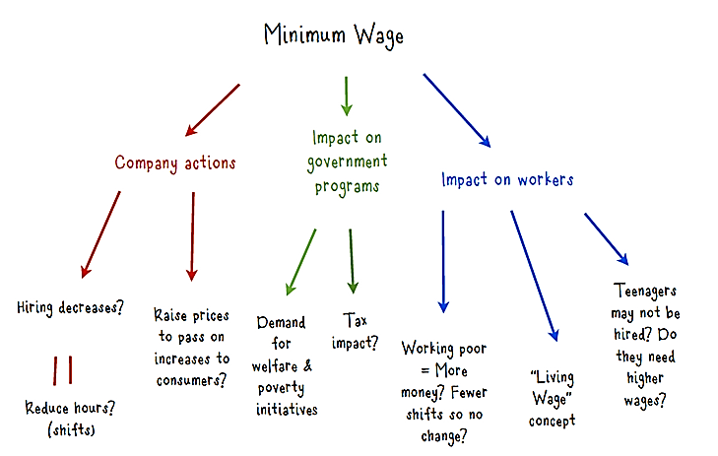
YOUR CONCEPT MAP

EXAMPLE OUTLINE
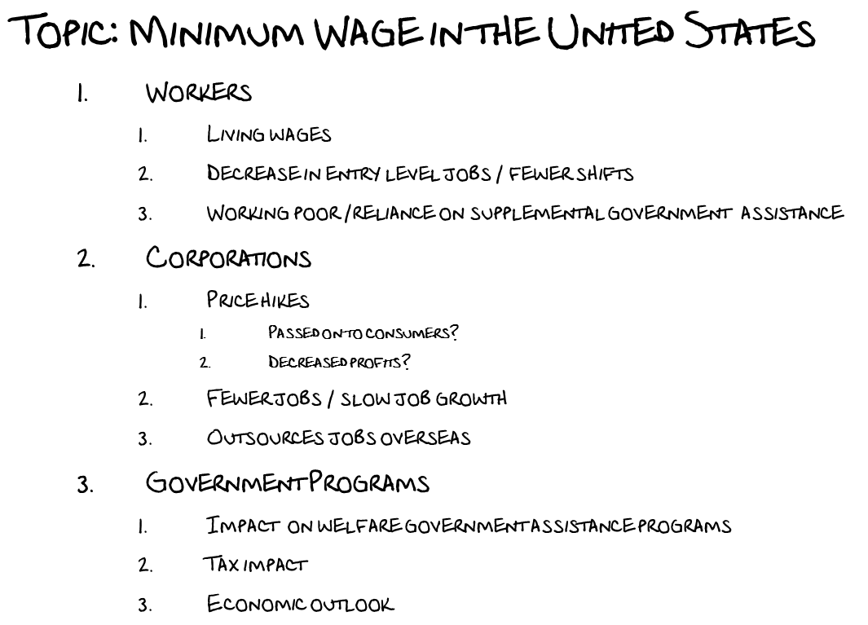
YOUR OUTLINE
G
Scholarly conversations surrounding your topic:
Which subject areas (disciplines) investigate and research your topic? Most library resources are arranged by subject areas (disciplines), including databases, books and even our Research Guides http://libguides.lmu.edu/. Knowing which academic discipline conducts research on your topic will help you find scholarly information more efficiently. Circle all that apply:
General & Multidisciplinary | African American Studies | Art & Art History | Asian Pacific American Studies | Biology | Business | Chemistry | Chicana/o Studies | Classics | Communication Studies | Computer Science | Dance | Economics | Education | Engineering | English | Environmental Science | Film & Television | Health & Human Sciences | History | Law | Mathematics | Modern Languages | Music | Sociology | Philosophy | Physics | Political Science | Psychology | Theatre Arts | Theology & Religion | Women’s Studies | Other (Please List) ___________________________________________

H
Incorporating diverse points of view:

What do I feel about this problem? How do my life experience and cultural, gender, race, ethnicity, and social class backgrounds influence my view of the problem? What assumptions do I hold about the issue/problem? How might someone from a different background view the problem?
In 2 or 3 sentences, please reflect…

What are my feelings about the information I am finding? Am I developing an open mind when encountering varied and sometimes conflicting perspectives? How does this new information compare to my existing knowledge about the topic? Am I surprised? Confused? Inspired? Are any of the sources challenging or uncomfortable?
In 2 or 3 sentences, please reflect…

How am I addressing other points of view? How does your approach integrate different perspectives on your topic? List all the intended parties/types of people and their points of view. What voices are missing? Look back at section C (Who) and section E (social group).
In 2 or 3 sentences, please reflect…

I
Topic feedback / instructor approval

My Written/Oral Assignment is: _____________________________________
My research topic is: ______________________________________________

Instructor Comments:

*Optional- writing workshop activity*
Pass the problem - In small groups or pairs students give and receive feedback from their peers on their social issue/problem topics.

J
Student Feedback

Student #1
Questions I still have about the research topic are:

Here is another perspective or point of view you may want to consider:

Student #2

Questions I still have about the research topic are:

Here is another perspective or point of view you may want to consider:

J. Holland and P.J. Henriot, Social Analysis: Linking Faith and Justice (Maryknoll, NY: Orbis Books, 1983), 199.
Questions adapted from: M. Cimperman, Social Analysis for the 21st Century: How Faith Becomes Action (Maryknoll, NY: Orbis Books, 2015).

