Exploring Marginalized Voices Handout

STEP 1 – Identify Relevant Voices

Starting Points:
The Marginalized Voices Honeycomb offers 6 broad categories of sources that can be publishing work on your topic. Fill out the honeycomb with the names of relevant sources that would be engaging with your topic.
Need help getting started? Try this template:
[Topic] AND [keywords for category]
E.g. “Land repatriation” AND (organization OR association OR foundation)
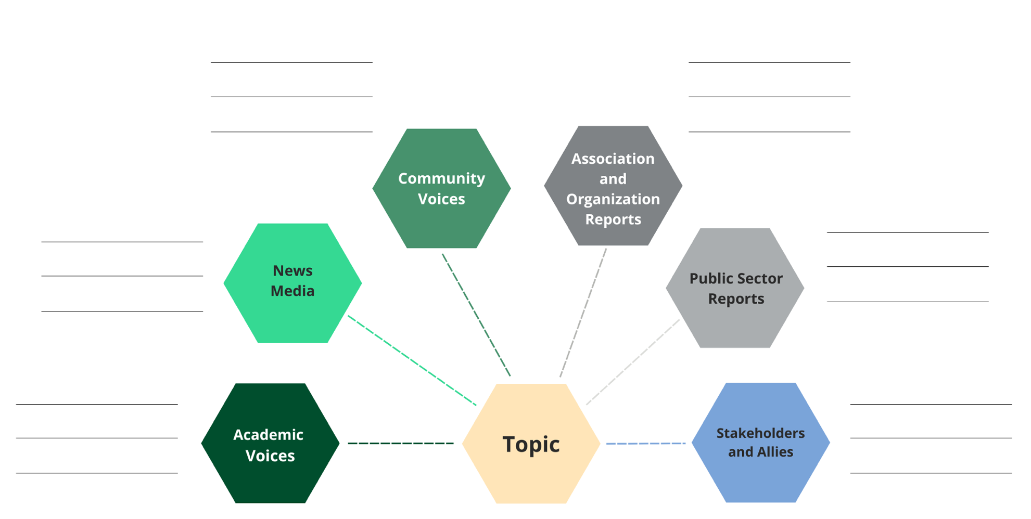

STEP 2 – Search & Documentation Strategies
Once you have brainstormed potential sources that are engaging with your topic, use a combination of the search tips below to locate information or material created by these communities.

Search Tips
- Using a variety of terms related to your topic, browse and/or search the websites of sources engaging with your research question (refer to the honeycomb you created). Use the website’s search bar to search a variety of word combinations.
- Use Web of Science to locate conference proceedings
- Advanced Google (use Advanced Google to search the websites of the relevant authorities/organizations identified in Step 1)
  - Copy & paste the organization’s URL into Advanced Google’s ‘site or domain’ field
  - Search with various word combinations using the most appropriate search box (e.g. “all these words”, “any of these words”, etc)
  - Select a particular file type (e.g. PDF, xls, word, txt) for Google to search. Limiting to the file type PDF or Word will most likely retrieve reports, whereas limiting to file type excel will most likely retrieve data sets.
  - Limit to specific countries using the Advanced Google region limits or search country-specific Google search engines such as Google UK, Google France
- Search social media or blogs to locate community voices
- Advanced Twitter Searching
  - NEAR: followed by coordinates of the event (you can get this from Google or Apple maps) or you can use the name of a city
  - Within: to set a km or mile radius around your location
  - Since: start date of interest
  - Until: end-date of interest
- Customized Google search engines to help you locate federal, provincial, or municipal documents
- Identify grey literature databases or collections which may publish documents related to the research question. These databases may be subject specific (i.e. Indigenous resources) or collections of specific forms of publications (i.e. theses, newspapers, conference proceedings, government docs)

Website Browsing Documentation:
Date | Organization name  E.g. 1492 Landback Lane | URL  Tip: For social media, include a screenshot | Notes and comments

Exploring Marginalized Voices Handout by Aneta Kwak, Jeff Newman, and Mikayla Redden is licensed under a Creative Commons Attribution-Non Commercial-Share Alike 4.0 International License.
This template was originally created by Jackie Stapleton and is based on the methods outlined in the article: Godin, K., Stapleton, J., Kirkpatrick, S. I., Hanning, R. M., & Leatherdale, S. T. (2015). Applying systematic review search methods to the grey literature: a case study examining guidelines for school-based breakfast programs in Canada. Systematic reviews, 4(1), 138. DOI: 10.1186/s13643-015-0125-0

