Library Warm-up Activity

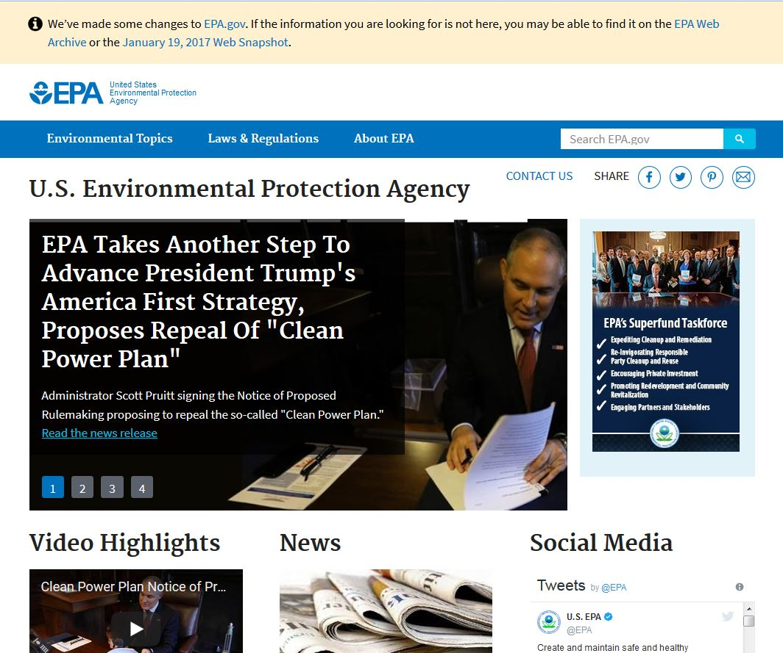
Go to the EPA website. Google it or go directly to https://www.epa.gov

- How many times is “climate change” or “climate” mentioned on today’s homepage?

- In the blue navigation bar at the top, click on Environmental Topics. How would you find the topic “Climate Change” on this page?

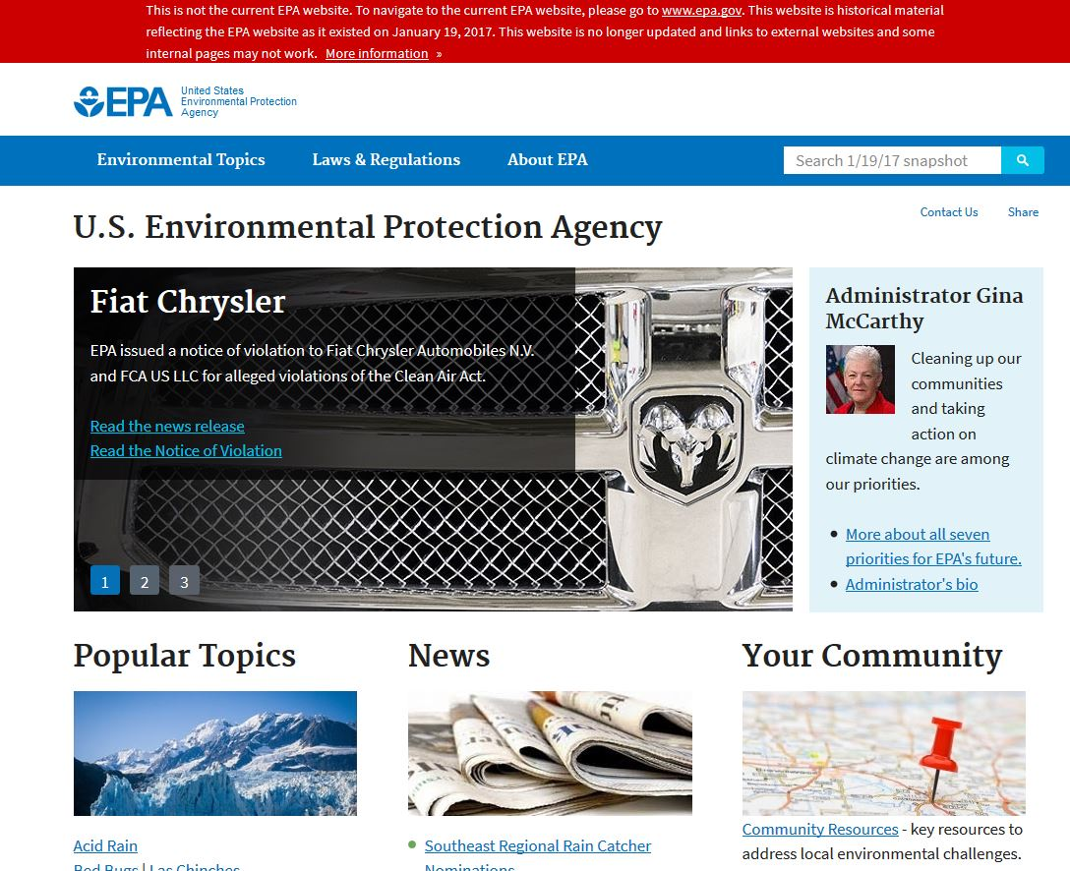
Go back to www.epa.gov and read the small text at the top of this page. Now click on January 19, 2017 Web Snapshot or go to https://19january2017snapshot.epa.gov/

Please read the red banner at the top.
- How many times is “climate change” or “climate” mentioned on the homepage from January 19, 2017?

In the blue navigation bar at the top, click on Environmental Topics. Then click on “Climate Change.” What do you see?

Go to the Internet Archive’s Wayback Machine. Google it or go directly to https://archive.org/web and type “EPA” into the search box. Click on the first result (www.epa.gov). Find a snapshot from January 31, 2008.
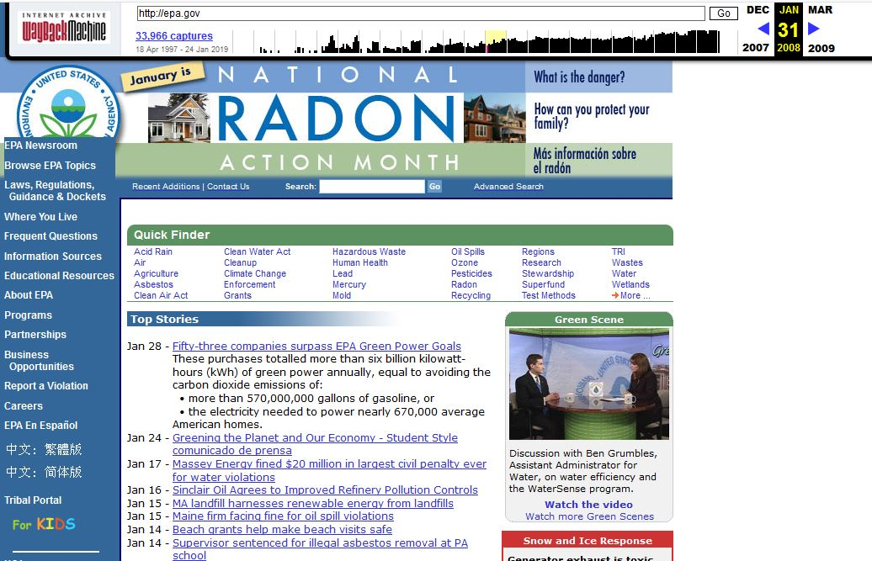
- How many times is “climate change” or “climate” mentioned on the EPA homepage from January 31, 2008?
_____________________________________________________________________________
Information Has Value -- Information or the lack of information can be used to influence people.
“Value may also be leveraged by individuals and organizations to effect change and for civic, economic, social, or personal gains.”

Discussion Questions
Please critically reflect on the EPA website as it appeared during the Trump, Obama, and Bush presidencies. Discuss with your partner.

- What might you expect to see that is missing/what’s missing from the new EPA website?

2. How does this impact our understanding of climate change?
  - How does this impact schoolchildren?
  - How does this impact voters and taxpayers?
  - How does this impact scientists?
  - How does this impact democracy?
- What social, economic, political, and power structures influence the production and dissemination of climate change information on the EPA website (or any government website)?
  - Who benefits? Who is burdened? (or who are the winners & losers?)
- How do government priorities impact research and data accessibility?

- Does this change the way you think about government websites. Why or why not?

