**Research Resource: The Card Game**

Apples to Apples but with information resources!

**Directions**: Break out into groups of 4-6 people

****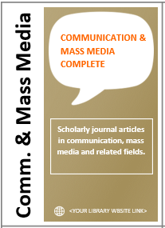

2)

Choose a player to be the first judge. The judge deals five gold resource cards to each player (including him or herself). Players may look at their cards.

1)

**Each player**: Take a purple card and write-in your research topic.

Game developed by Zoeanna Mayhook and Kari Whitney at the University of Washington Tacoma Library. Adapted from Mattel Apples to Apples Game Rules. CC-BY-NC 4.0



Journalism

The judge reads the gold resource cards aloud, and picks the most useful resource for their topic, and explains their reasoning.

Before each round, players can pick one new gold card from the stack. The next judge is the player to the left. Follow steps 3-6 until all purple cards have been played. Everyone is a winner!

6)

5)

4)

3)

The judge reads the research topic from the first purple card aloud, and then places it face-up on the table.

Each player (except the judge) chooses one gold card from their hand that would be the best resource for the research topic provided, and then gives their selection to the judge.