Scale of Scholarly Publishing

Key Takeaways
- Scholarly publishing is an industry whose products range from books to journal articles to data. Millions of articles are published every year from hundreds of countries around the world.
- (Advanced/Extension) Only four to five major publishers control the majority of scholarly articles published, which leads to rising prices and less choice for libraries when negotiating contracts for purchasing access to content.

Lesson Content
Below you will find a variety of ways to briefly address this topic. Pick, choose, and adapt as you like.

Quick Mentions
- In 2016, approximately 2.2 million scholarly articles were published across the globe. The United States produces the most articles, followed closely by China. [AJE Scholarly Publishing Report, 2016]
- The first journals were produced in the eighteenth century as a way for members of scientific societies to share their discoveries with one another. In the four centuries since, publishing has become a multibillion-dollar industry that facilitates the dissemination of articles, books, and data.
- The Duke Libraries pay over $13 million a year on subscriptions (i.e., journals and databases) so students, faculty, and researchers can have access to the latest literature.
- Authors are not paid to produce and publish articles, but readers have to pay for access; libraries are buying back content their institution’s researchers produce for free.
- (Advanced/Extension) Publishing has been consolidated into almost a near-oligopoly held by four major publishers: Reed-Elsevier, Wiley-Blackwell, Springer, and Taylor & Francis. These companies reap massive profits every year by charging universities to buy back the content their researchers produce. And they keep buying up smaller journals every year.
- (Advanced/Extension) Not all journals charge to access their content. Open access journals have a different business model, in which fees are usually charged to authors and articles are free to read online.

Discussion Questions
- What is the predominant medium of sharing research in your field and how does that affect the way you access current literature?
- Where in the life cycle of publication are you, as an undergraduate researcher, situated?
- As many journals shift from print to digital format, and are no longer producing and disseminating physical issues, should subscription costs go down? Why or why not?
- Buying a physical book is a one-time cost for the library, but a journal subscription is something that has to be renewed annually. Without the subscription, the library may lose access to the journal’s content. Is that really “buying” a subscription or “leasing” the research?

Visuals and Media
- The publication life cycle graphic from the University of Winnipeg library
- From “Know Your Sources” infographic from Portland Community College
- A table comparing the profit margins of major companies with publishers. Illustrates the high profit margins of scholarly publishers, Taylor & Francis and Elsevier
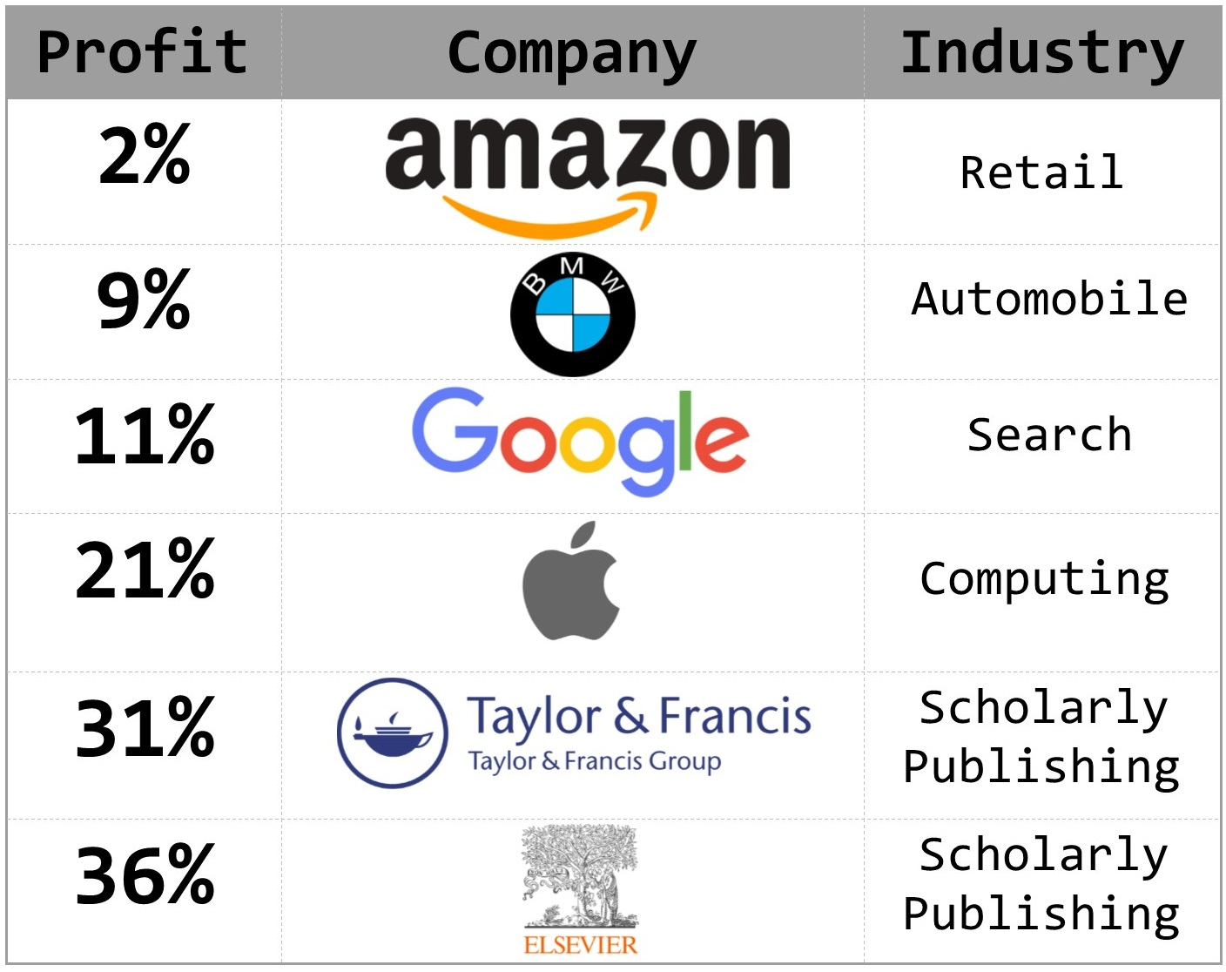

Student Readings
- Mudrak, B. (2016). Scholarly Publishing in 2016: A Look Back at Global and National Trends in Research Publication. Retrieved from https://www.aje.com/en/arc/scholarly-publishing-trends-2016/ (See the Global Data Report.)
- Floris, H. (2015). From Submission to Sharing: The Life Cycle of an Article. Retrieved from https://www.elsevier.com/authors-update/story/publishing-tips/life-cycle-of-an-article

