Selecting Visualization Types Activity Plan (Activity #2)

Google Form:
https://docs.google.com/forms/d/e/1FAIpQLSc6okplRh6GFroJG8Uq4fK83b5hHnt9OWHkToW3aZws6WZZaw/viewform?usp=sf_link

Format: Multiple choice
- Bar, Line, Pie, Histogram, Map

Additional resources to share with students:
- Data Visualization LibGuide: https://libguides.lmu.edu/digcitizen/dataviz

Activity Images, Questions, and Answers
Each scenario includes the scenario presented to students, the answer(s), and a visual to include in the slides when going over the answers (if available)

Scenario #1: Water Usage
Scenario: Using average residential data from the American Water Works Association, how would you visually represent the percent of total water usage each water-using household item uses? The categories include shower, toilet, faucet, washing machine, leaks, and other.

Answer(s):
- Pie! Rare situation where a pie chart would work well (displays parts of a whole)

Visual Source: https://www.statisticshowto.com/probability-and-statistics/descriptive-statistics/pie-chart/

Scenario #2: COVID-19 Data
Scenario: Based on COVID-19 data from the “Los Angeles County Case Summary,” how would you visually represent the number of cases by Race/Ethnicity in Los Angeles County?

Answers(s): Bar

Visual Source: http://publichealth.lacounty.gov/media/coronavirus/locations.htm

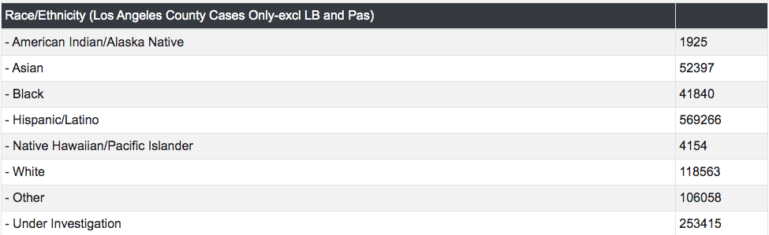

Scenario #3: Living Languages
Scenario: Based on data from the World Atlas of Language Structures (WALS) database, 2,678 living languages currently exist in the world. How would you visually represent the languages corresponding with the birthplace of each language?

Answer(s):
- Map

Visual Source: http://www.puffpuffproject.com/languages.html

Scenario #4: COVID-19 Data
Scenario: Based on the data from Los Angeles County on COVID-19 cases, how would visually represent the number of cases per age group within LA County?

Answer(s):
- Histogram

Visual Source: http://publichealth.lacounty.gov/media/coronavirus/locations.htm

Scenario #5: Pet Products
Scenario: Using the data from American Pet Products, how would you visually represent the number of households that own a pet by pet type (bird, cat, dog, horse, freshwater fish, saltwater fish, reptile, small animal)?

Answer(s):
- Bar graph

Visual Source: Self-created.

