The Information Spectrum Lesson Plan

Description:

This concept map and activity explores how various sources of information are created, accessed, and shared. Students collaboratively define what makes a source traditional, emerging, public, or exclusive. Students are given a type of information source to map on the grid according to each axis, and provide a rationale for their placement.

Learning Outcomes:
After the activity, students will be able to:
- articulate the traditional and emerging processes of information creation and dissemination
- articulate the value and constraints of public and exclusive information
- assess the fit between an information product’s creation process and a particular information need

Materials Needed:

- Projector
- Information Spectrum image (Google Drive folder with GIMP/PNG vector files)
- Slips of paper
- Tape

Directions:

If possible, project the concept map image/slides onto a whiteboard to take notes, write examples, or tape sources directly to the board.

- Introduce the concept map: The x-axis follows a continuum from traditional to emerging sources, while and the y-axis follows a continuum from public to exclusive sources. Depending on the context, sources may fall anywhere in each of the four quadrants.
- Collaboratively define terms: Before giving set definitions for each axis label, ask students what they associate with each word, taking notes for the class on the whiteboard of within the slide.
- Map example source types: Give each student a typed slip of paper with a information source type and a piece of tape to place on the Information Spectrum map. Examples of source types might include:
I. Emerging-Exclusive:
- dataset
- online peer-reviewed journal article
- ebook found in a library catalog
II. Traditional-Exclusive:
- print book published by a university press
- conference poster
- encyclopedia entry in a reference book
III. Traditional-Public:
- print magazine
- novel
- flyer on a bulletin board
IV. Emerging-Public:
- online news article
- Tweet
- blog post

- Discussion: Ask each student to talk about why they placed their source where they did according to the characteristics discussed. The facilitator should affirm students’ decisions while including additional considerations if necessary.
- Optional Additional Sources: If students are asked to find or evaluating specific sources related to their assignment, return to the Information Spectrum concept map to chart each example and discuss.

Classroom Example:

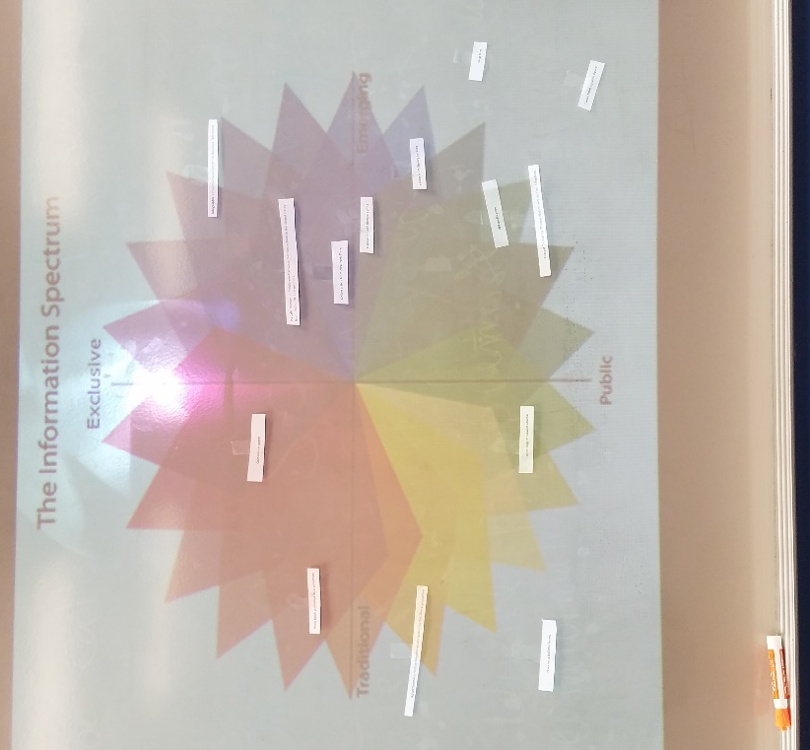

Assessment:

In an online discussion forum or post-session survey, ask students to describe sources they might use for their assignment or for a given scenario according to the Information Spectrum.

