Trump Twitter Feed – Metaphor and Enthymeme Practice

- (3:13 AM - 28 Feb 2016) Donald J. Trump Verified account ‏@realDonaldTrump
"@ilduce2016: “It is better to live one day as a lion than 100 years as a sheep.” – @realDonaldTrump #MakeAmericaGreatAgain"
- 4:09 PM - 6 Nov 2016 Donald J. Trump Verified account ‏@realDonaldTrump
Our American comeback story begins 11/8/16. Together, we will MAKE AMERICA SAFE & GREAT again for everyone!
- 4 Nov 2016 Donald J. Trump Verified account ‏@realDonaldTrump
If Obama worked as hard on straightening out our country as he has trying to protect and elect Hillary, we would all be much better off!
- 2:30 PM - 2 Nov 2016

Thank you Orlando, Florida! We are just six days away from delivering justice for every forgotten man, woman and child in this country!

- Donald J. Trump ‏@realDonaldTrump Oct 28 Manchester, NH
We must not let #CrookedHillary take her CRIMINAL SCHEME into the Oval Office. #DrainTheSwamp
- Donald J. Trump ‏@realDonaldTrump Oct 27
Obamacare is a disaster. We must REPEAL & REPLACE. Tired of the lies, and want to #DrainTheSwamp? Get out & VOTE #TrumpPence16 & lets #MAGA!
- Donald J. Trump ‏@realDonaldTrump Oct 23
"If you can't run your own house you certainly can't run the White House" A statement made by Mrs. Obama about Crooked Hillary Clinton
- Donald J. Trump ‏@realDonaldTrump Oct 3 Pueblo, CO
We must bring the truth directly to hard-working Americans who want to take our country back. #BigLeagueTruth

- Donald J. Trump ‏@realDonaldTrump Oct 19
University of Nevada, Las Vegas
The era of division is coming to an end. We will create a new future of #AmericanUnity. First, we need to #DrainTheSwamp! #Debates

- Donald J. Trump ‏@realDonaldTrump Oct 19
#CrookedHillary is nothing more than a Wall Street PUPPET! #BigLeagueTruth #Debate
- Donald J. Trump ‏@realDonaldTrump Oct 18 United States
Hillary is the most corrupt person to ever run for the presidency of the United States. #DrainTheSwamp
- Donald J. Trump Verified account ‏@realDonaldTrump
Watched Saturday Night Live hit job on me. Time to retire the boring and unfunny show. Alec Baldwin portrayal stinks. Media rigging election!
4:14 AM - 16 Oct 2016

- Donald J. Trump ‏@realDonaldTrump Oct 15
Nothing ever happened with any of these women. Totally made up nonsense to steal the election. Nobody has more respect for women than me!
14) Official Team Trump ‏@TeamTrump Oct 4
We need STRONG, BROAD-SHOULDERED leadership like @mike_pence & @realDonaldTrump in the White House! #VPDebate #BigLeagueTruth
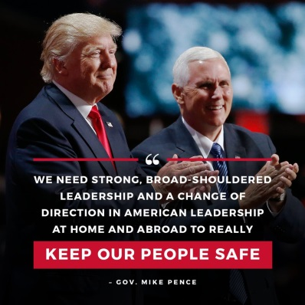

15) Donald J. Trump ‏@realDonaldTrump Oct 4 Arizona, USA
My childcare plan makes a difference for working families - more money, more freedom. #AmericaFirst means #FamilyFirst!

16) Donald J. Trump ‏@realDonaldTrump Sep 30
Did Crooked Hillary help disgusting (check out sex tape and past) Alicia M become a U.S. citizen so she could use her in the debate?
17) Donald J. Trump Retweeted Official Team Trump ‏@TeamTrump Sep 26
When @realDonaldTrump is POTUS, families are going to be safe and secure. Law and order will be RESTORED! #MAGA #Debates #Debates2016
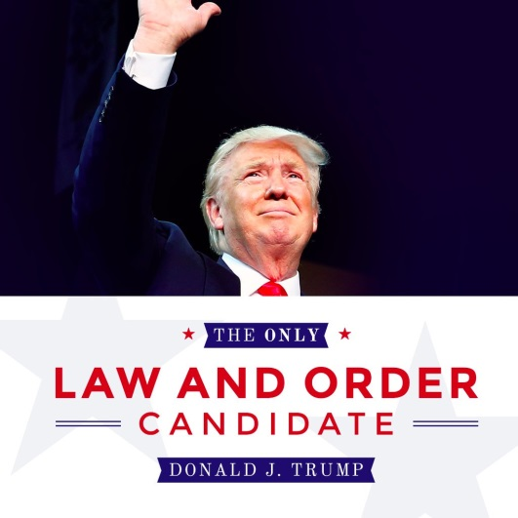

18) Donald J. Trump ‏@realDonaldTrump Sep 21
It is a MOVEMENT - not a campaign. Leaving the past behind, changing our future. Together, we will MAKE AMERICA SAFE AND GREAT AGAIN!
19) Donald J. Trump ‏@realDonaldTrump Sep 20
Hillary Clinton is taking the day off again, she needs the rest. Sleep well Hillary - see you at the debate!

20) Donald J. Trump ‏@realDonaldTrump Sep 17
Wacky @NYTimesDowd, who hardly knows me, makes up things that I never said for her boring interviews and column. A neurotic dope!
Donald J. Trump ‏@realDonaldTrump Sep 17
.@CNN just doesn't get it, and that's why their ratings are so low - and getting worse. Boring anti-Trump panelists, mostly losers in life!

