Contribute to Fremont Wiki -
https://localwiki.org/fremont/

Create a free Fremont Wiki account in the upper right-hand corner of the Fremont Wiki homepage.

Pick a topic, then search to see if an entry for it has already been created.

Create a Page
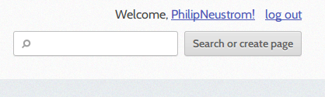
In order to create a new page, first search for the title of the entry you want to create in the box labeled.
I want to make a page about

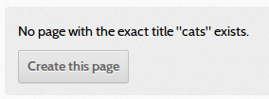
If there's no exact match, you will see a button with the option to “Create this page.”

Click “Create this page” to start editing your new page.

Edit a Page
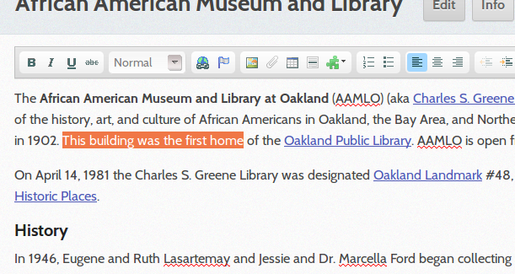
Once you have created a page, you can begin editing. You will see a space to add text, and above that an editing toolbar with formatting options (see right).

In addition to adding text, you can upload images, insert links, format text, and more. There are options for all of these in the editing toolbar. To see what a button does, hover your mouse over it.

Before saving, you can add a comment describing what you changed (e.g., “added some history”). This gives a summary for other people about what changed with each save. This is entirely optional though.
Once you're done editing, click the 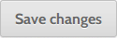 button at the very bottom of the page. You can exit the editing screen at any time by clicking the “Cancel” button next to the “Save changes” button.

Editing
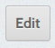
To get back into the entry, search for it again, then click on the "Edit" button right next to the page's name on top. Remember to save changes, and if you want to, add a comment about what changes were made.

Tags
At the bottom of every entry, you'll see an “Edit tags” button. If you click this, you can add categories for your entry (e.g., “history,” “neighborhood,” “store”). Type the tag and hit “Enter” after you are done writing it. You can add multiple tags this way and then click “Save” when you're done. If you want to see a list of all the entries that have the same tag, click the tag itself.

Cite your sources!
Find at least one good credible source of information for your entry. Post a link at the bottom. We will be formatting these into citations during the next class.

Other Optional Tools - Create a Map – Not Required!
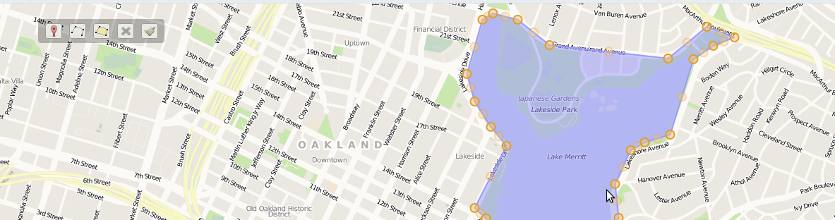
To add a map to an entry, go to the entry, click “Edit,” then click “Edit Map” at the bottom of the screen. You can zoom in and out of the map using the plus/minus buttons, and move the map using either the up/down arrows or clicking on and dragging the map.

Use this marker to add points.
Use this tool to draw lines. Click the icon then click on the map to start the line. You can continue to add as many pieces to your line as you want. Double click on your last point to end the line.
Use this tool to draw a region (e.g., parks, neighborhoods, etc.). Click the icon then click on your starting point. Continue until you create a solid shape. To finish, double click on your last point.
This is the delete tool. Select it and click the elements you want to delete from the map.
This tool will clear everthing from the map.

When you are finished making your map, click Save changes to save.

